ACHARHABI | Abdelmalek | 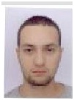
AIT OUARABI | Chems Eddine | 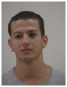
AYADI | Leila | 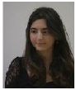
AZOUNI | Sarra | 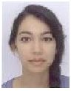
BARDE | Maxime | 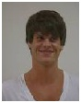
Ben Makhlouf Andalou | Yassine | 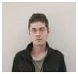
BENE | Brice | 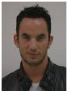
BOURDIN | Marie | 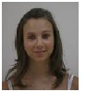
CARRIOU | Vincent | 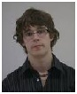
CARVALHO GUEDES | Fabio | 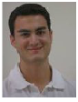
CHAN | Mickaël | 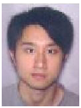
CHAPELLE | Julien | 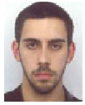
CHASSERIEAU | Thomas | 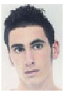
CHEBAK | Soraya | 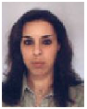
CHIOZZOTTO | Maxime | 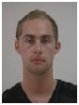
COLLASSE | Emilie | 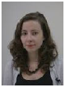
COMMERE | Alexis | 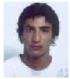
DE TEMMERMAN | Paul | 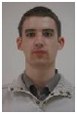
du Peloux | Flavien | 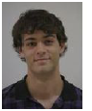
FLEURY | Charles | 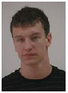
FOREST BARBIER | Dan | 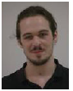
GASPARI | Jérémy | 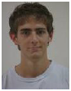
GENETET | Come | 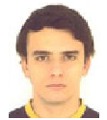
JOUANNY | Yohann | 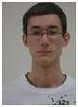
KARAMPOURNIS | Stephane | 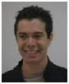
LACAGNE | Maxime | 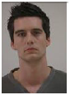
Laloyaux | Adrien | 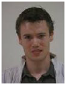
Le Courtois Du Manoi | Gauthier
Lebouter | Thibault | 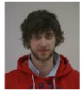
Lerideau | Florian | 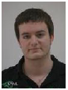
Longret | Thibault | 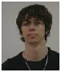
Mamou Mani | Philippe | 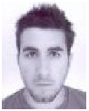
Masson | Yannick | 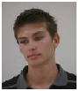
Mohamed | Christian | 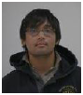
Morgana | Delphine | 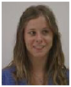
Nicoletti | Etienne | 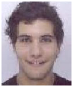
Pertuc | Matthis | 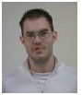
Piette | Julien | 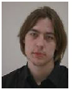
Poinsignon | François | 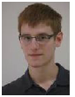
Polycarpe | Felix | 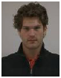
Rakotonoah | Sitraka | 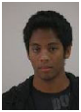
Richecoeur | Hugo | 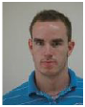
Sallon | Nicolas | 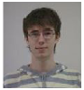
Seddiki | Jadir | 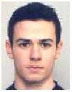
Shakoor | Modesar | 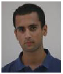
Soumal | Alexander | 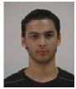
Tasdelen | Nilgun | 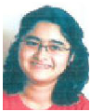
Teixeira | Adrien | 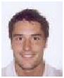
Thavarajah | Nishanth | 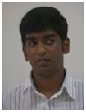
Tissot | Florian | 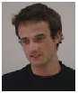
Trehard | Quentin | 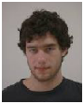
Tréhen | Geoffroy
VANTROEYEN | Guillaume | 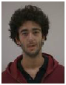
Weinberger | Nicolas | 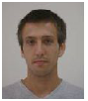
Wolff | Priscilla | 