ALGER | Vivien | 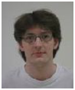
AYADI | Leila | 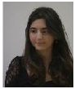
AZOUNI (?) | Sarra | 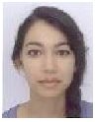
BADA | Anne-Sophie | 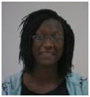
BADUEL | Thomas | 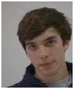
BANDOU | Marion | 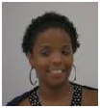
BARTOLO | Aurélien | 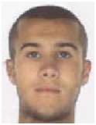
BOUHDADI | Adil | 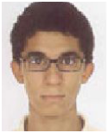
BOUHDOUD | Maria | 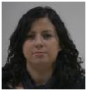
CAPEL | Benjamin | 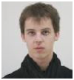
CASEY | Alexandre | 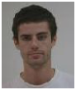
CHEBAK | Soraya | 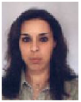
CISSE | Fafa | 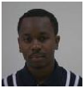
DELMAS | Jean | 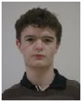
DJOUMAIDI HADHURAMI | Sarah | 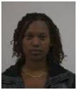
DOUCET | Nicolas | 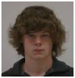
DUVERNOIS | Hugues | 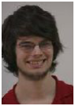
FARGEON | Ilan | 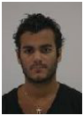
FICHTALI ( ?) | Mehdi | 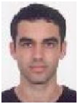
FOREST BARBIER | Dan | 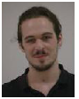
GAUQUELIN | Benoit | 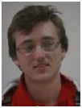
GENETET | Come | 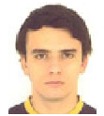
GERVAISE | Romain | 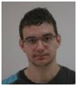
GHEYOUCHE | Aunss | 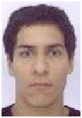
GLENCK | Nicolas | 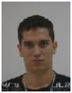
GOUBIN | Yann | 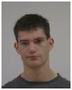
LARRIEU ( ?) | Thomas | 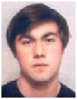
LAURENT | Jean-Paul | 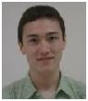
LE BOUTER | Thibault | 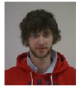
MARTINETTO ( ?) | Marie-Liesse | 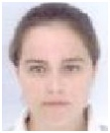
NDONG OWONE | Christophel | 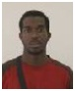
NGUYEN-TRUNG | Jimmy | 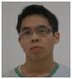
POLYCARPE | Félix | 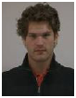
PUSTIENNE | Brian | 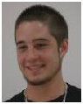
SASSOUI | Abdelkader | 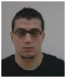
SHAKOOR | Modesar | 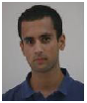
SI YOUCEF | Massinissa | 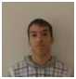
SIVACOUMAR | Daniel | 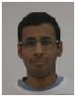
TEIXEIRA ( ?) | Adrien | 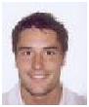
THAVARAJAH | Nishanth | 