 | 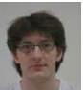 | 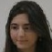 | 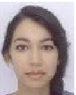. | 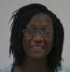 | 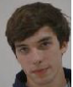
ABUZOUR | ALGER | AYADI | AZOUNI | BADA | BADUEL
Fayçal | Vivien | Leila | Sarra | Anne-Sophie | Thomas
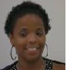 | 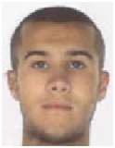 | 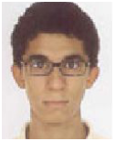 | 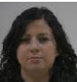 | 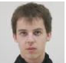
BANDOU | BARTOLO | BOUHDADI | BOUHDOUD | CAPEL | CARRIOU
Marion | Aurélien | Adil | Maria | Benjamin | Vincent
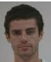 | 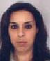 | 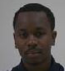 | 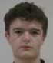 | 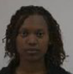 | 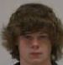
CASEY | CHEBAK | CISSE | DELMAS | DJOUNAIDI HADHURAMI | DOUCET
Alexandre | Soraya | Fafa | Jean | Sarah | Nicolas
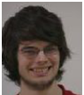 | 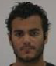 | 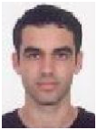. | 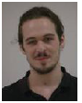 | 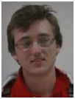 | 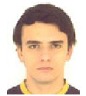
DUVERNOIS | FARGEON | FICHTALI | FOREST BARBIER | GAUQUELIN | GENETET
Hugues | Ilan | Mehdi | Dan | Benoit | Come
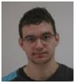 | 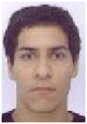 | 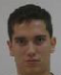 | 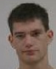 | 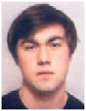. | 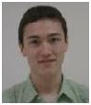
GERVAISE | GHEYOUCHE | GLENCK | GOUBIN | LARRIEU | LAURENT
Romain | Aunss | Nicolas | Yann | Thomas | Jean-Paul
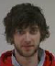 | 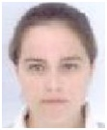. | 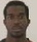 | 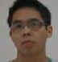 | 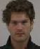 | 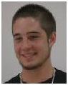
LE BOUTER | MARTINETTO | NDONG OWONE | NGUYEN-TRUNG | POLYCARPE | PUSTIENNE
Thibault | Marie-Liesse | Christophel | Jimmy | Félix | Brian
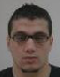 | 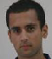 | 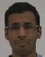 | 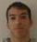 | 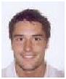. | 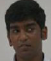
SASSOUI | SHAKOOR | SIVACOUMAR | SI YOUCEF | TEIXEIRA | THAVARAJAH
Abdelkader | Modesar | Daniel | Massinissa | Adrien | Nishanth

