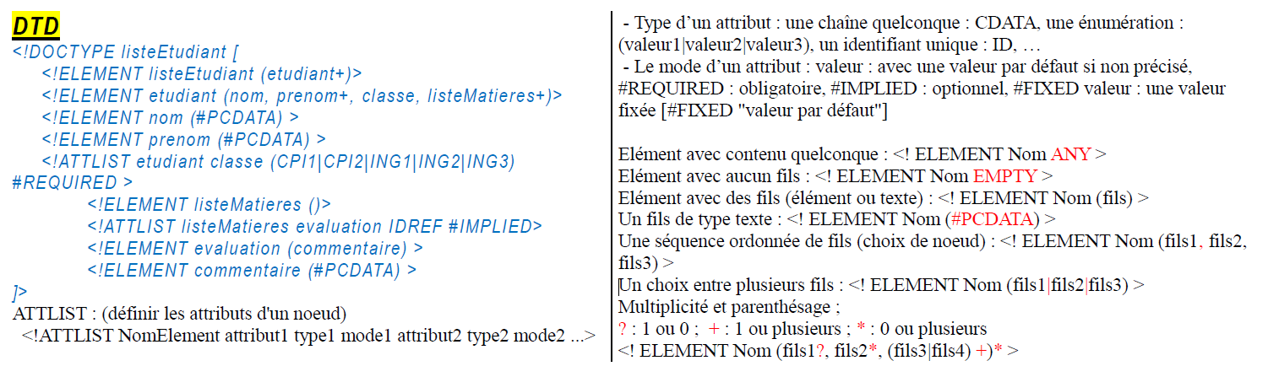
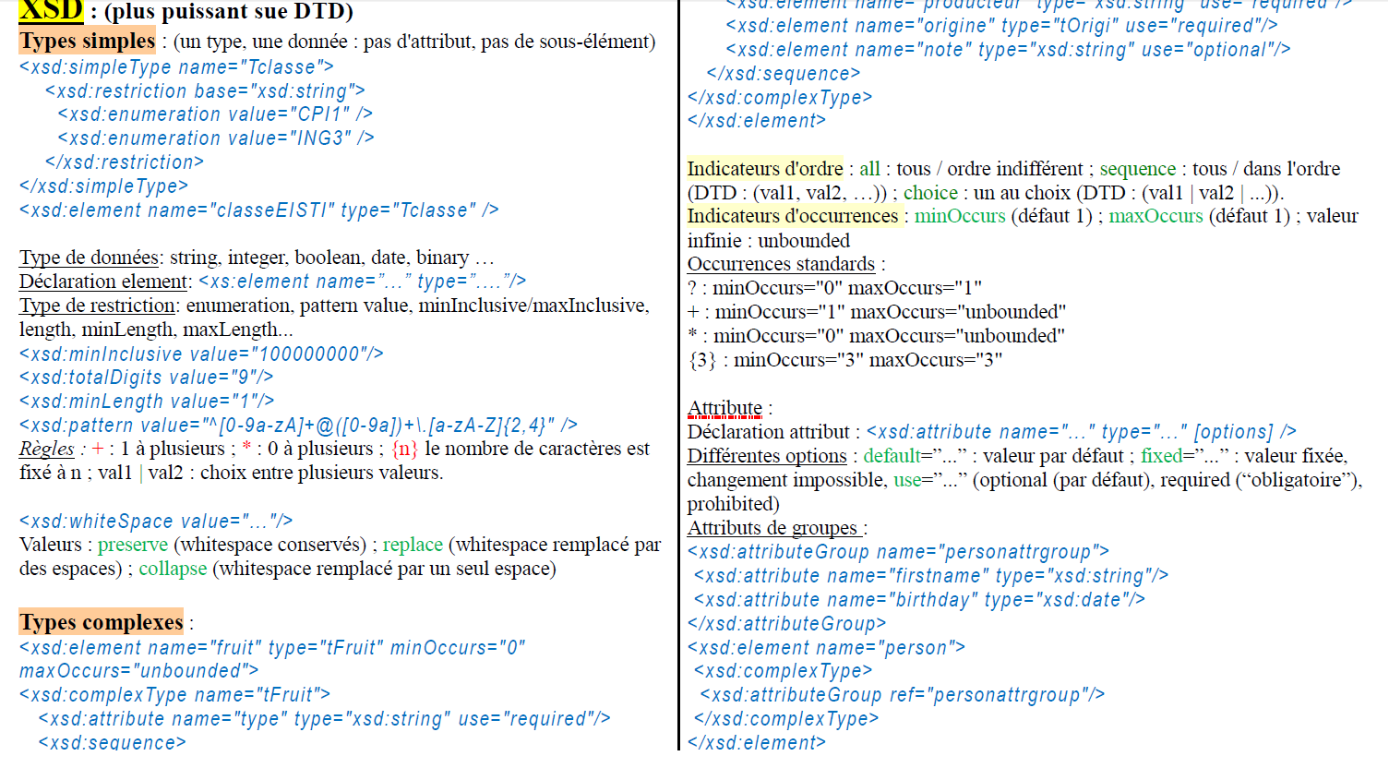
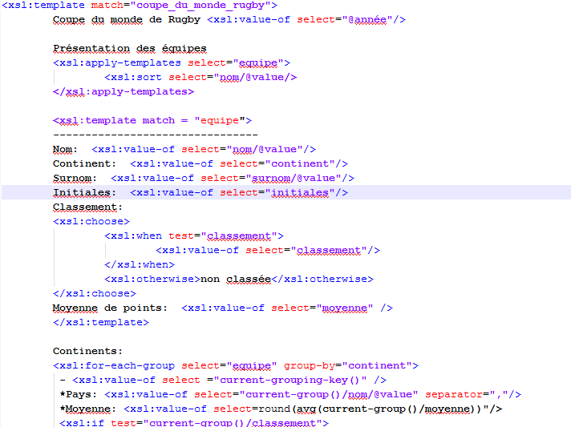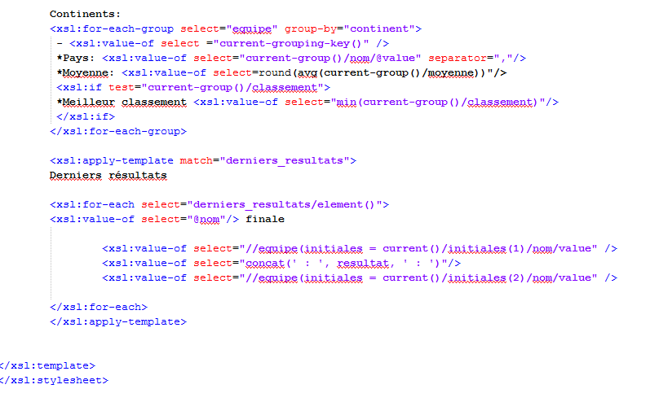

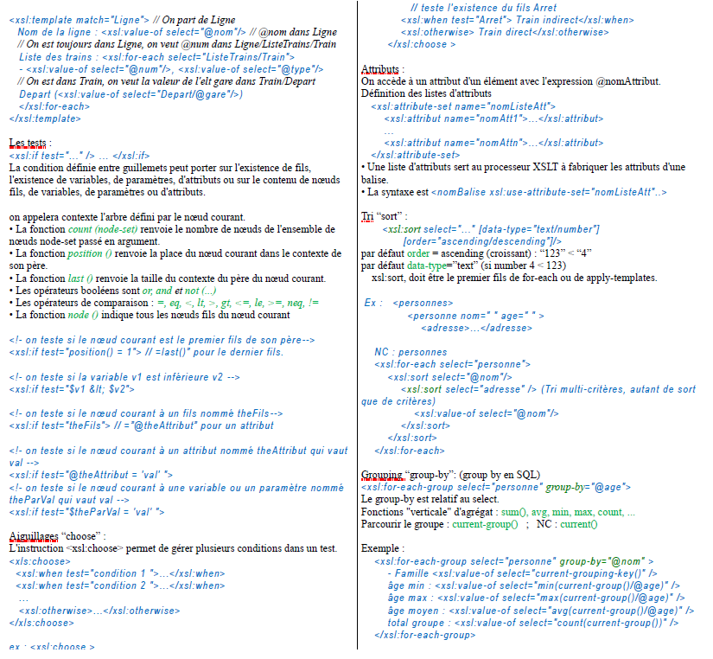
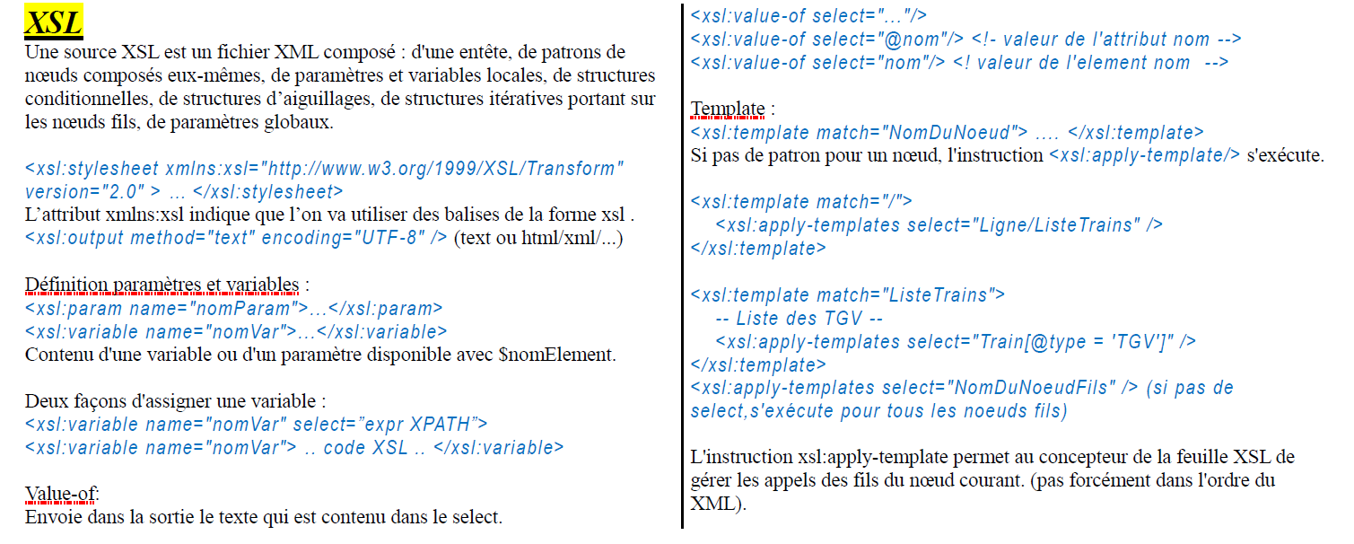
<xsl:value-of select="preceding-sibling::nom/@value" />
Q1b: <xsl:value-of select="../nom/@value" />
Q2: <xsl:value-of select="following::equipe/initiales" separator=", "/>
Q3: <xsl:value-of select="//equipe[upper-case(substring(nom/@value,1,1)) = 'A']/surnom/@value" separator=", "/>
Q4: <xsl:value-of select="//derniers_resultats/finale[initiales = current()]/resultat" separator=", "/>

